Benchmarking PSU’s data services against U Iowa and U Michigan

Robyn Reed

I highlighted things a little more “unique.” For example, in the example below you see that data management plans, data documentation and repositories are pages within the guide. These should be in anything we do and seemed a bit obvious (for a lack of a better term). But we should keep them in mind.

**U Iowa** <http://guides.lib.uiowa.edu/data>

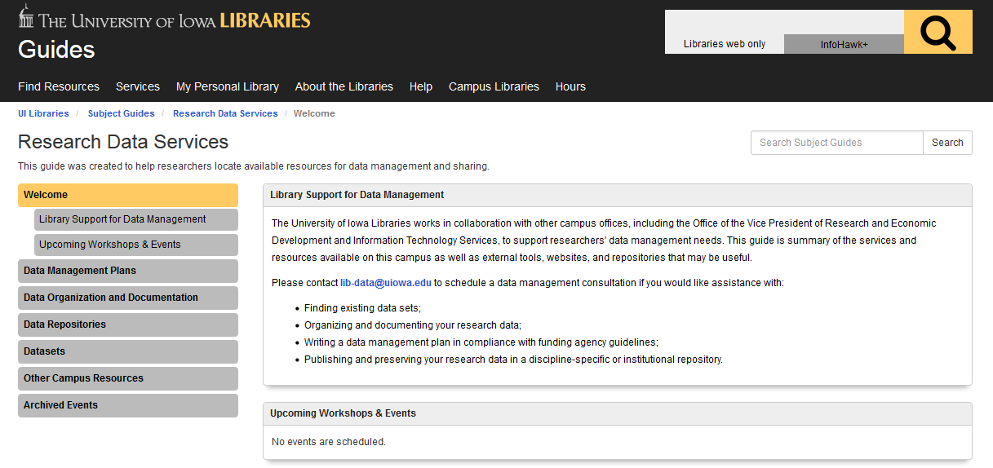

Works with Office of the Vice President of Research and Economic Development and Information Technology Services

They have an email address for consultations and feature the following as services:

* Finding existing data sets;
* Organizing and documenting your research data;
* Writing a data management plan in compliance with funding agency guidelines;
* Publishing and preserving your research data in a discipline-specific or institutional repository.

They break out the types of datasets available

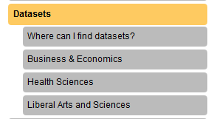

Iowa shows additional resources within departments or schools for more specialized information

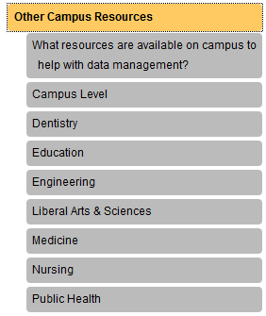

e.g. Public Health has a biostats service center as well as clinical trials stats

**U Michigan**

<http://www.lib.umich.edu/research-data-services>

Article about the initiative

<https://record.umich.edu/articles/library-launches-research-data-services-and-deep-blue-data>

My favorite quote: There are more than 50 librarians, informationists and staff working on this initiative, with expertise ranging from the creation of data-management plans, metadata schematics, publication, visualization and preservation.

Wow……………

Much of the UM site describes similar services offered by any library that would have data services. E.g. data management planning, discovery and access, organization/management, preservation…

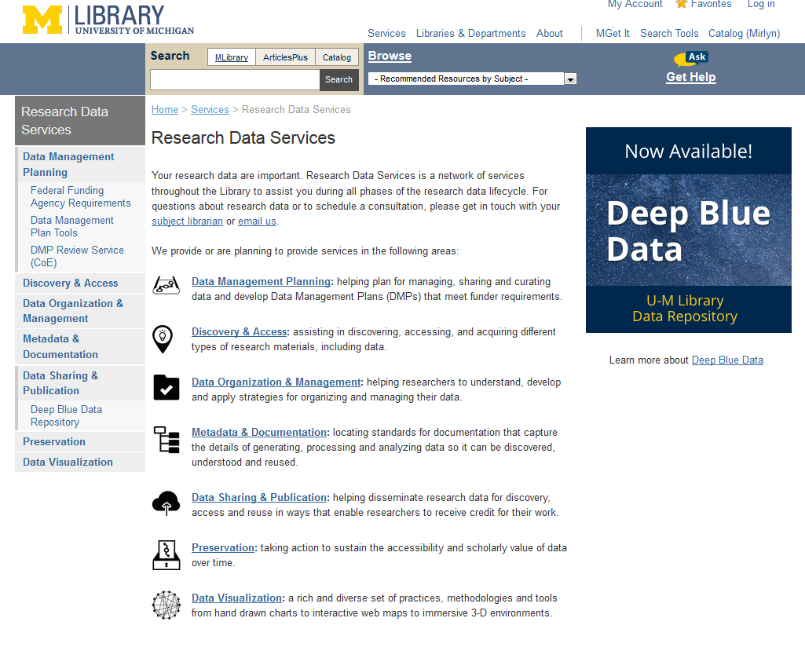

Additional information they include is on metadata and data visualization.

They also have information on data sharing and publications, which could fall into similar categories. I have a data management libguide which mentions data sharing policies but I don’t spend a lot of time on it. Their approach of sharing and publishing is a good thing to think about.

It appears that they have a general email as well and will put requesters in touch with the right person either in the library or elsewhere on campus. This leads me to believe there are a handful of partnerships.

They also have a DMP review service for the College of Engineering. (I’m not saying we should do this – just noting they have it!)

**Who will review my DMP?**

A librarian and an IT person will review your DMP. Someone from the Associate Dean for Research Office  may also review your DMP if the librarian or IT reviewer have questions that they need help with.